


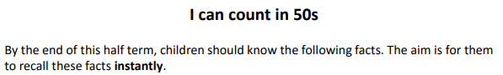

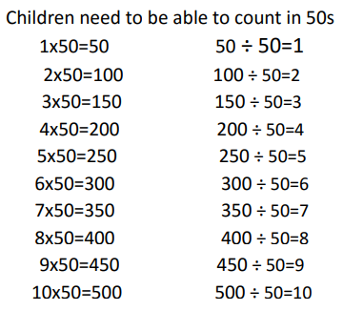

Key Vocabulary
How many 50s make 300?
Multiply 50 by 6
What are 4 lots of 50?
What is 50 times 7?
What are 5 groups of 50?

Top Tips
- The secret to success is practising little and often. Use time wisely. Can you practise these KIRFs whilst walking to school or during a car journey? You do not need to practise them all at once: perhaps you could have a fact of the day.
- Look at the patterns with both objects and numbers. E.g. When counting in 50s, what do you notice about the end digit?
- Try counting in 50s from 0 or any multiple of 50. As an extra challenge, could your child start at a number that is not a multiple of 50 and count in 50s from there?
- Buy One Get Three Free – If your child knows one fact (e.g. 3 x 50 = 150), can they tell you the other three facts in the same fact family?
- www.Snappymaths.com has some suitable games for counting in 50s.

Make it Real!


Three children in Nightingales class were given 50 team ticks each because they worked really hard in a maths lesson. How many team ticks did they receive altogether?
150! How do you know? Because 3 lots of 50 is equal to 150.


We are going to bake 6 cakes. Each cake requires 50 grams of flour. How many grams do we need to make all 6 cakes?
300 grams of flour! Explain why. Because the product of 6 and 50 is 300.

How many 50s are in 250?
5! How do you know? I know that there are 5 lots of 5 in 25 so there must be 5 groups of 50 in 250.

Make it Fun!
Call out!
Play number ping-pong. Start by saying ‘ping’ and the child replies with ‘pong’.
Repeat and then convert to numbers i.e. say ‘50’ and they reply ‘100’

What’s hidden?
There are 100 beans on this place, I hide 50 under a cup- how many are left?

Playing cards (take out the picture cards and use joker as zero)
Pull out a card and count in 50s as many times as it says in the card. Once you have reached the answer, say the ful number sentence. E.g. if you pull a 4, count up to 200 ad then say ‘4 multiplied by 50 equals 200).

Dominoes
Do the same as above but using dominoes.

Timed games (important that if you do this, the child understands the importance of focusing on the improvement that they are making).
How many questions can you answer in 2 minutes? Can you beat your own record?

