

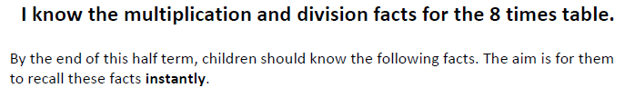

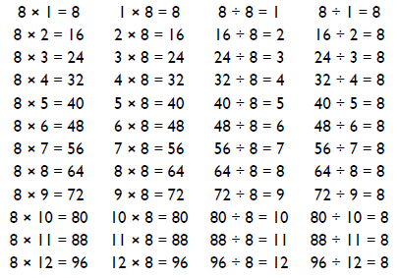
Key Vocabulary
What is 8 multiplied by 10?
What is 7 times 8?
What is the product of 8 and 4?
What is 48 divided by 8?
How many groups of 8 can you make out of 56?

Top Tips
- The secret to success is practising little and often. Use time wisely. Can you practise these KIRFs while walking to school or during a car journey? You don’t need to practise them all at once: perhaps you could have a fact family of the day.
- Songs and Chants – you can buy times tables CDs or find multiplication songs and chants online. If your child creates their own song, this can make the times tables even more memorable.
- Use Times Tables Rock stars.
- Double your fours – multiplying a number by 8 is the same as to multiply by 4 and then double the answer. 8 x 4 = 32 and double 32 is 64, so 8 x 8 = 64.
- Five six seven eight – fifty six is seven times eight (56= 7 x 8).

Make it Real!

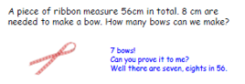
There are 8 smarties on each bun. If we make 6 buns how many smarties will we need?
48 smarties!
Can you explain why?
8 lots of 6 are 48.


A vending machine I broken and only takes 5p coins. How many coins will you need to buy a chocolate bar that costs 40 pence?
8 coins! How do you know? 5 lots of 8 are 40p.

Make it fun!
Call out! Play ‘Beat the calculator’. One person works out the answer to a multiplication or division question with a calculator and the other person works it out in their head. Who is quicker?
Play Fizz Buzz To practise the 5 and 8 times tables together, take it in turns to count in ones. If a number is in the 5 x table say ‘fizz’ instead of the number and ‘buzz’ if it’s in the 8s and ‘fizz buzz’ if it’s in both.
Dice Roll a dice and generate a two-digit or three-digit number. Discuss whether the number is divisible by 8. How do you know?
Playing Cards Remove picture cards from the pack. Pick a card and state the multiplication and division fact for the four times table. E.g. pick the ‘9’ card so 9 x 8 = 72, 8 x 9 = 72, 72 ÷ 8 = 9, 72÷ 9 = 8.
Dominoes To practise the 8 times table, pick a domino and add together the dots. The child multiplies the total by 8 and then give the associated division fact.
Songs and rhymes There are lots of CDs/ Apps available with musical tables. Great fun to sing along to on long car journeys!
Timed Games How well are you doing? How many questions can you answer in 2 minutes? Can you beat your own record?

