
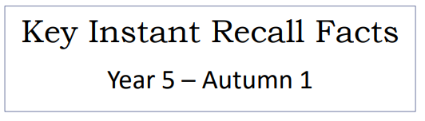

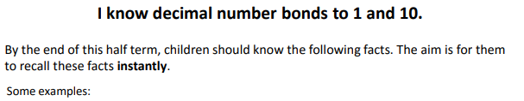

Key Vocabulary
What do I add to 0.8 to make 1?
What is 1 take away 0.6?
What is 1.3 less than 10?
How many more than 9.3 is 10?
What is the difference between 0.7 and 10?

wha

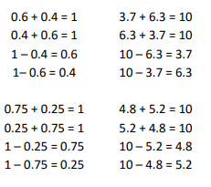
This list includes some examples of facts that children should know. They should be able to answer questions including missing number questions e.g. 0.4 + O = 10 or 10 – O = 7.2
Top Tips
- The secret to success is practising little and often. Use time wisely. Can you practise these KIRFs while walking to school or during a car journey? You don’t need to practise them all at once: perhaps you could have a fact of the day. Create regular, short opportunities for rapid-fire questions where an instant correct answer is required.
- Use objects to consider the bonds in a practical way.
- Look at the patterns with both objects and numbers e.g. as one number increases the other one decreases
- Practise with the numbers both in order and chosen randomly- remember the aim is to be able to answer immediately.
- Buy one get three free - If your child knows one fact (e.g. 8.4 + 1.6 = 10), can they tell you the other three facts in the same fact family? (1.6 + 8.4 = 10, 10 – 1.6 = 8.4, 10 – 8.4 = 1.6)
- How can decimal number bonds to one help you work out decimal number bonds to 10?
- Play games – There are missing number questions at www.conkermaths.com. See how many questions you can answer in just 90 seconds. There is also a number bond pair game to play.
Make it real!
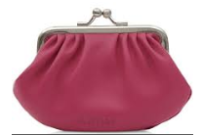
Jack has £10, he spends £6.30. How much change does he get?
£3.70! Are you sure? Yes, the sum of £3.70 and £6.30 is £10.
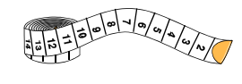

I have 10 cm of ribbon and I cut off 4.3 centimetres. How much ribbon do I have left?
5.7 cm! Why? Because 5.7 add 4.3 makes 10.
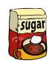
A bag of sugar contains 10kg. If I use 3.4kg how much will I have left?
6.6kg! How do you know? The difference between 10kg and 6.6kg is 3.4kg.
Make it fun!
Call out!
Play number ping-pong. Start by saying ‘ping’ and the child replies with ‘pong’.
Repeat and then convert to numbers i.e. say ‘2.6’ and they reply ‘7.4’ (decimal number bonds to 10).

What’s hidden?
I have 10 grams of beans. There are 4.6 grams on this plate, how many grams are hidden under the cup? (Decimal number bonds to 10.)

Playing cards (remove picture cards and the 10s)
Play snap treating each card as tenths. When you have a pair which total 1, shout ‘snap’ and explain why. E.g. 0.2 + 0.8 = 1
Dominoes
Pick a domino from a set facing down. Choose one side to represent the whole number and the other side to be the tenth. How many more to reach 10.
Dice
Roll 2 die, treat the first one as the whole number and the second as the tenth. How many more to make 10?

Timed games (important that if you do this, the child understands the importance of focusing on the improvement that they are making).
How many questions can you answer in 2 minutes? Can you beat your own record?

