


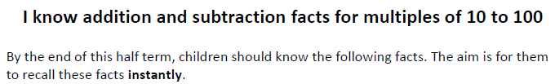

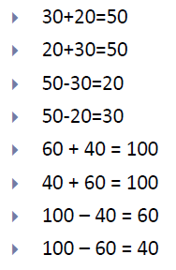
Some Examples
Key Vocabulary
What do I add to 60 to make 100?
What is 100 take away 60?
What is 70 minus 40?
What is 20 less than 50?
How many more than 60 is 100?
What is the difference between 50 and 30?

Top Tips
- The secret to success is practising little and often. Use time wisely. Can you practise these KIRFs while walking to school or during a car journey? You do not need to practise them all at once: perhaps you could have a fact family of the day.
- Buy one get three free – if your child knows one fact (e.g. 30 + 40 = 70) can they tell you the other three facts in the same fact family?
- Use number bonds to 10 – How can number bonds to 10 hep you work out number bonds to 100?
- Play games – there are missing number questions at www.conkermaths.com. See how many questions you can answer in just 90 seconds. There is also a number bond pair game to play.


Make it Real!
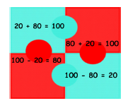

If I put 60 pence into my piggy bank, how much more do I need to put in to make it £1?
40 pence! How do you know?
Because £1 is equal to 100 pennies and 100 subtract 60 is 40.


There are 100 pages in my book. I have read 30 of them; how many pages do I have left until I have finished the book?
70 pages! Explain why.
Because 100 take away 30 is 70 and 70 plus 30 is the same as 100.
Remind children that if they know 6 + 3 = 9 then they also know that 3 +6 =9, 60 + 30 = 90, and that 600 +300 = 900.

Make it Fun!
Call out! Tap a number of regular beats. Ask the child to count silently in tens; calling out the number you stop on.

What’s hidden? Have a bag of ten ten pence pieces. Ask the child to select a random number of coins from the bag and quickly call out the change from a pound. Check by looking at how many coins are left in the bag.

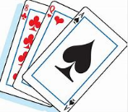
Playing cards Remove picture cards from the pack. Hold up a card and child replies with the number needed to equal 100. 2 becomes worth 20, 4 becomes 40 etc.


Songs and rhymes There are lots of songs available to support number bonds e.g. 10 green bottles or 10 in a bed. Play online you can play number bond games online at www.conkermaths.com.
Timed Games How well are you doing? How many questions can you answer in 2 minutes? Can you beat your own record?

