Keep the noise down Max!
L.O: Recognise that sounds get fainter as the distance from the sound source increases.
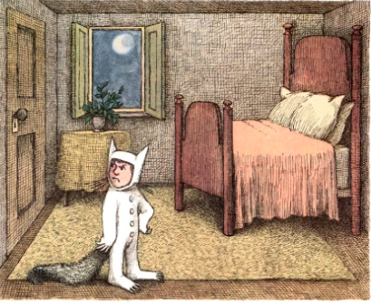
When Max visits the Wild Things, his parents can’t hear them because they are a relatively long way away. However, what if Max wanted to smuggle one (or more) of them back to visit him in his room?
Have you ever played with your friends, played video games or music too loudly in your room and been told to, “Keep that noise down!”?
Well your job is to work out the best material to muffle the sounds coming from Max’s room so his parents don’t find out he’s invited the Wild Things into his room. Using the materials in Max’s room design an experiment to answer the question: Which material (thing) muffles to sound best?
Watch this man try to muffle the noise from next door: https://www.stem.org.uk/resources/elibrary/resource/32039/how-muffle-sound
Think about:
- What are you going to change?
- What are you going to measure?
- How are you going to do the experiment?
- How to make your test fair? What things do you need to keep the same?
- How are you going to record your results? Are you going to draw a graph?
Then when you have completed your experiment you need to say what your results show. Which sound insulation is best? Why?

